***Directions: Provide a snippet of each figure in the tutorials below.***

**Tutorial 3-1 (Pg. 126):**

1. Figure 3-2:

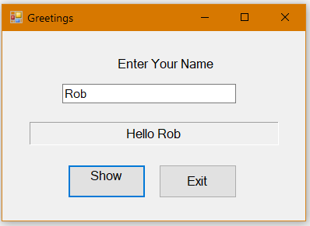

**Tutorial 3-2 (pg. 128):**

1. Figure 3-5:

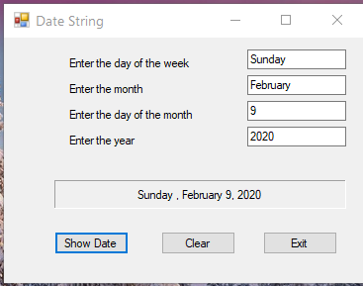

**Tutorial 3-3 (pg. 138):**

1. Figure 3-8:

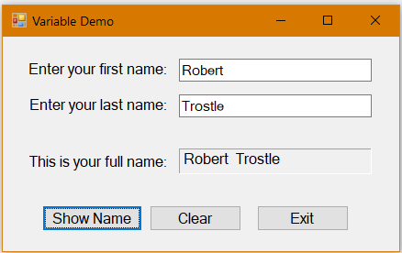

***Continuation of Snippets:***

**Tutorial 3-4 (pg. 155):**

1. Figure 3-16:

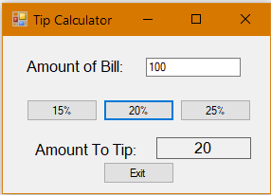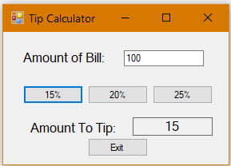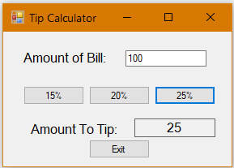

**Tutorial 3-5 (pg. 163):**

1. Figure 3-18:

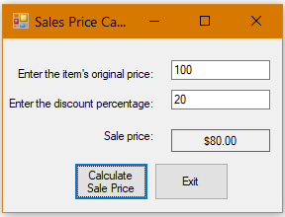

**Tutorial 3-6 (pg. 168):**

1. Step 11, testing the coin images:

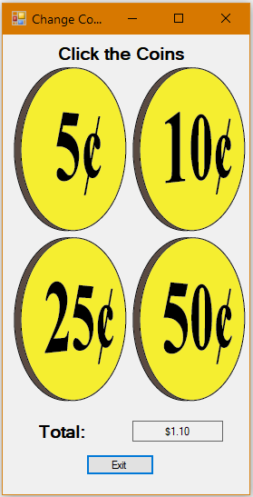

***Continuation of Snippets:***

**Tutorial 3-7 (pg. 173):**

1. Figure 3-23, Error message:

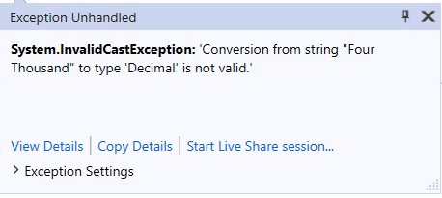

**Tutorial 3-8 (pg. 177):**

1. Figure 3-28, Error message:

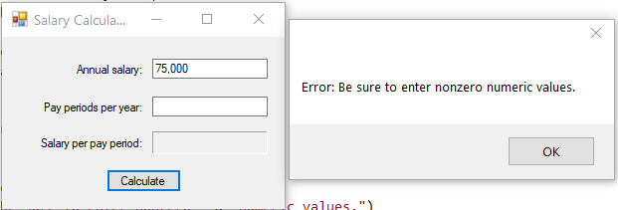

**Tutorial 3-9 (pg. 193):**

1. Figure 3-41:

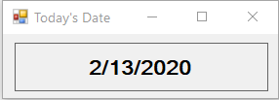

**Tutorial 3-10 (pg. 200):**

1. Figure 3-50:

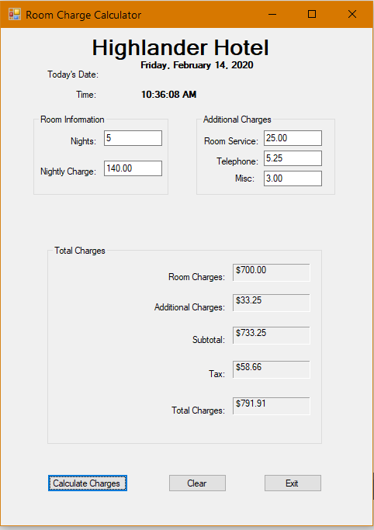

**Tutorial 3-11 (pg. 206):**

1. Step 5, display the label in white text with blue background:

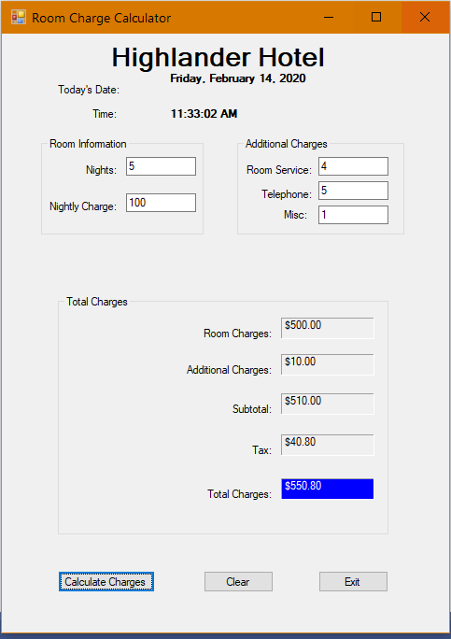

**Tutorial 3-12 (pg. 209):**

1. Step 14, displaying the step into commands for debugging: F8

